Lab Report No13

Introduction to Filters in Digital Signal Processing (DSP): FIR and IIR
Digital Signal Processing



Submitted By:
[Huzaifa Shahbaz]
[21-CE-009]

Submitted to:
Engr. Hareem Khan
Dated:
31thMay,2024

Department of Computer Engineering,
HITEC University, Taxila
Lab Example No 1:

Solution:
Brief description (3-5 lines)
An FIR filter is designed by finding the coefficients and filter order that meet certain
specifications, which can be in the time-domain (e.g. a matched filter) and/or the frequency
domain (most common). Matched filters perform a cross-correlation between the input
signal and a known pulse-shape. The FIR convolution is a cross-correlation between the

input signal and a time-reversed copy of the impulse-response. Therefore, thematched-
filter's impulse response is "designed" by sampling the known pulse-shape and using those

samples in reverse order as the coefficients of the filter.
The code
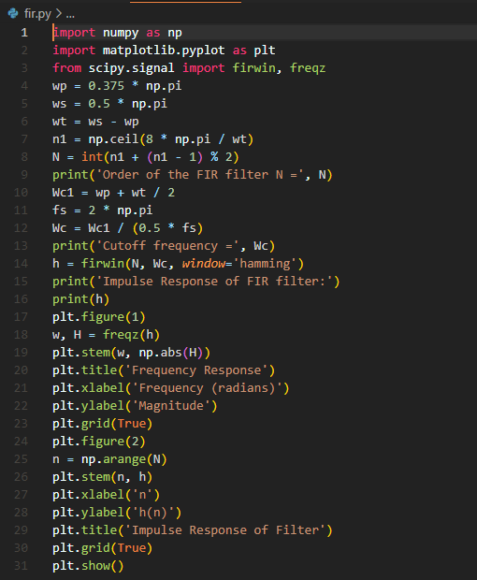
The results (Screenshot)
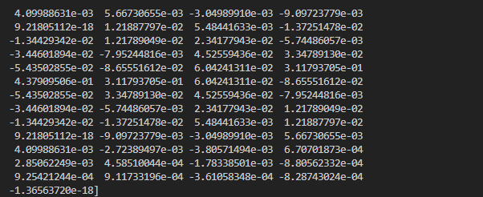
GRAPH:
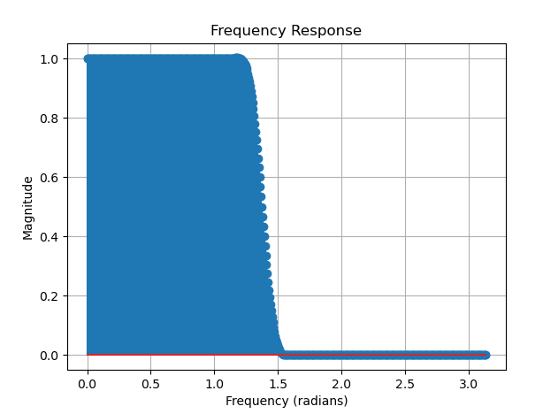
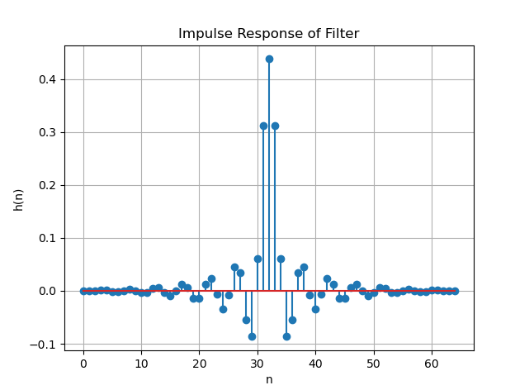
Lab Example No 2:

Solution:
Brief description (3-5 lines)
An FIR filter is designed by finding the coefficients and filter order that meet certain specifications, which can be in the time-domain (e.g. a matched filter) and/or the frequency domain (most common). Matched filters perform a cross-correlation between the input signal and a known pulse-shape. The FIR convolution is a cross-correlation between the input signal and a time-reversed copy of the impulse-response. Therefore, the matched-filter's impulse response is "designed" by sampling the known pulse-shape and using those
samples in reverse order as the coefficients of the filter.
The code
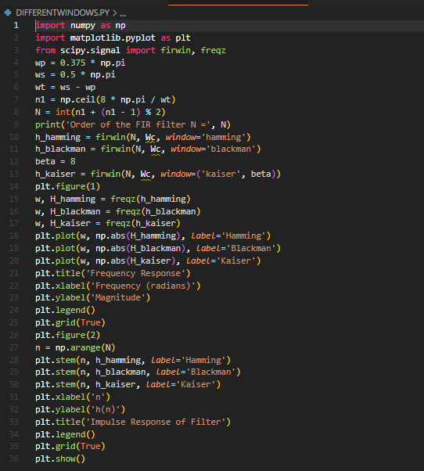
The results (Screenshot)
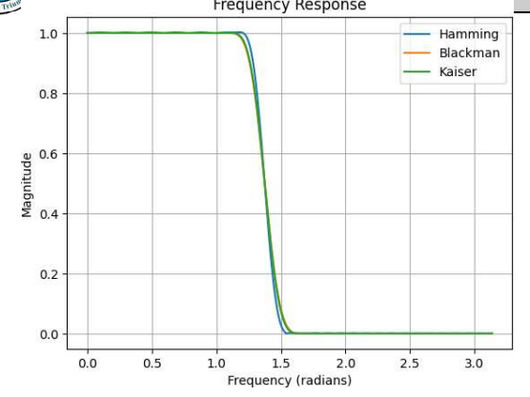
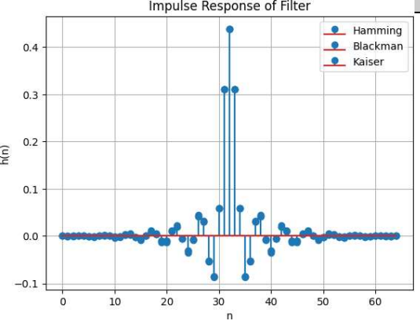

Lab Example No 3:

Solution:
Brief description (3-5 lines)
IIR filters are digital filters with infinite impulse response. Unlike FIR filters, they have the feedback (a recursive part of a filter) and are known as recursive digital filters therefore. For this reason IIR filters have much better frequency response than FIR filters of the same order. Unlike FIR filters, their phase characteristic is not linear which can cause a problem to the systems which need phase linearity. For this reason, it is not preferable to use IIR filters in digital signal processing when the phase is of the essence. Otherwise, when the linear phase characteristic is not important, the use of IIR filters is an excellent
solution.
The code
import numpy as np
import matplotlib.pyplot as plt
from scipy.signal import butter, cheby1, freqz
from scipy.constants import pi
# Step I: Enter the pass band ripple (rp) and stop band ripple (rs)
rp = 0.1
rs = 40
# Step II: Enter the pass band frequency (wp) and stop band frequency (ws)
wp = 0.375 * pi
ws = 0.5 * pi
# Step III: Get the sampling frequency (fs)
fs = 2 * pi
# Step IV: Calculate normalized pass band frequency, and normalized stop band frequency w1 and w2 respectively
w1 = 2 * wp / fs
w2 = 2 * ws / fs
# Step V: Calculate the filter order
# Butterworth filter order
# [n, wn] = buttord(w1, w2, rp, rs)
# Chebyshev filter order
# [n, wn] = cheb1ord(w1, w2, rp, rs)
# Example filter order and wn values for demonstration
n = 6
wn = 0.4
# Step VI: Design an nth order digital low pass Butterworth or Chebyshev filter
# Butterworth filter
b, a = butter(n, wn)
# Chebyshev filter
# b, a = cheby1(n, rp, wn)
# Step VII: Find the digital frequency response of the filter
w, H = freqz(b, a)
# Step VIII: Calculate the magnitude of the frequency response in decibels (dB)
mag = 20 * np.log10(abs(H))
# Step IX: Plot the magnitude response [magnitude in dB Vs normalized frequency]
plt.figure(1)
plt.plot(w, mag)
plt.title('Magnitude Response')
plt.xlabel('Normalized Frequency')
plt.ylabel('Magnitude (dB)')
plt.grid(True)
# Step X: Calculate the phase response using angle(H)
phase = np.angle(H)
# Step XI: Plot the phase response [phase in radians Vs normalized frequency (Hz)]
plt.figure(2)
plt.plot(w, phase)
plt.title('Phase Response')
plt.xlabel('Normalized Frequency')
plt.ylabel('Phase (radians)')
plt.grid(True)
plt.show()
The results (Screenshot)
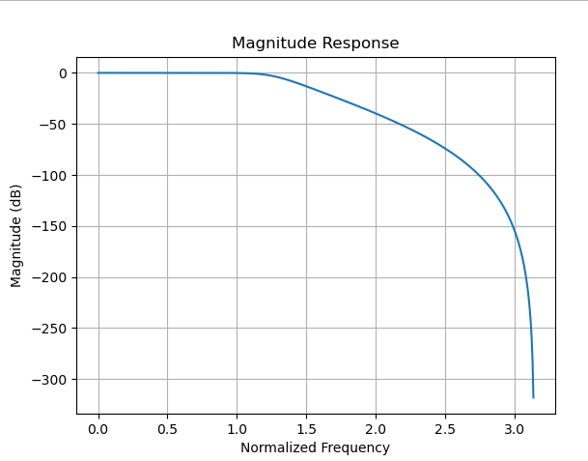
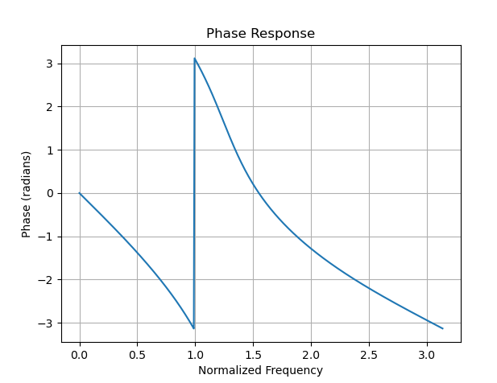

Lab Example No 4:

Solution:
Brief description (3-5 lines)
IIR filters are digital filters with infinite impulse response. Unlike FIR filters, they have the feedback (a recursive part of a filter) and are known as recursive digital filters therefore. For this reason IIR filters have much better frequency response than FIR filters of the same order. Unlike FIR filters, their phase characteristic is not linear which can cause a problem to the systems which need phase linearity. For this reason, it is not preferable to use IIR filters in digital signal processing when the phase is of the essence. Otherwise, when the linear phase characteristic is not important, the use of IIR filters is an excellent
solution.
The code
import numpy as np
import matplotlib.pyplot as plt
from scipy.signal import butter, cheby1, ellip, freqz
# Filter specifications
order = 4
cutoff_freq = 0.2 # Normalized cutoff frequency
# Design the Butterworth filter
b_butter, a_butter = butter(order, cutoff_freq, btype='low', analog=False, output='ba')
# Design the Chebyshev Type I filter
rp_cheby1 = 1 # Passband ripple in dB
b_cheby1, a_cheby1 = cheby1(order, rp_cheby1, cutoff_freq, btype='low', analog=False, output='ba')
# Design the elliptic filter
rp_ellip = 1 # Passband ripple in dB
rs_ellip = 40 # Stopband attenuation in dB
b_ellip, a_ellip = ellip(order, rp_ellip, rs_ellip, cutoff_freq, btype='low', analog=False, output='ba')
# Compute the frequency response for each filter
w, h_butter = freqz(b_butter, a_butter)
w, h_cheby1 = freqz(b_cheby1, a_cheby1)
w, h_ellip = freqz(b_ellip, a_ellip)
# Plot the magnitude response for each filter
plt.figure()
plt.plot(w, np.abs(h_butter), label='Butterworth')
plt.plot(w, np.abs(h_cheby1), label='Chebyshev Type I')
plt.plot(w, np.abs(h_ellip), label='Elliptic')
plt.title('Magnitude Response')
plt.xlabel('Frequency (radians)')
plt.ylabel('Magnitude')
plt.legend()
plt.grid(True)
# Plot the phase response for each filter
plt.figure()
plt.plot(w, np.angle(h_butter), label='Butterworth')
plt.plot(w, np.angle(h_cheby1), label='Chebyshev Type I')
plt.plot(w, np.angle(h_ellip), label='Elliptic')
plt.title('Phase Response')
plt.xlabel('Frequency (radians)')
plt.ylabel('Phase (radians)')
plt.legend()
plt.grid(True)
plt.show()
The results (Screenshot)
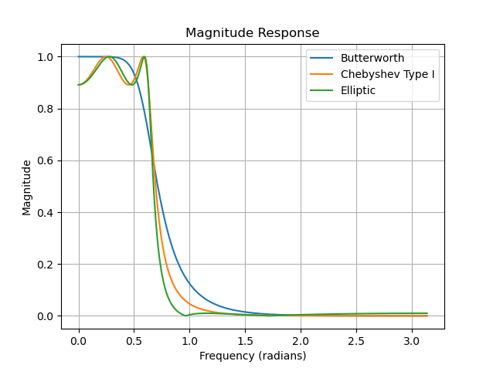
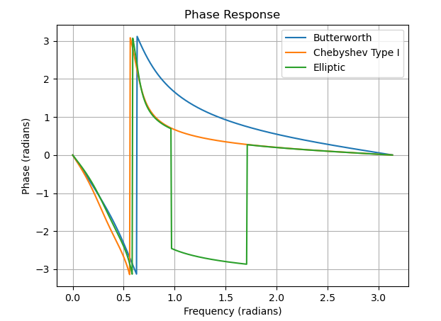
Lab Task No 1:

Solution:
Brief description (3-5 lines)
Hamming Window
Write a Python program to design an FIR filter using the Hamming window. Perform the following steps:
Define the input specifications: wp = 0.375 * np.pi, ws = 0.5 * np.pi.
Calculate the order of the filter using the formula N = int(np.ceil(8 * np.pi / (ws - wp)) + 1).
Calculate the cutoff frequency: Wc = (wp + (ws - wp) / 2) / (0.5 * np.pi).
Calculate the filter coefficients using the Hamming window: h_hamming = firwin(N, Wc,window='hamming').
Plot the frequency response and impulse response for the Hamming window.
Display the plots.
The code
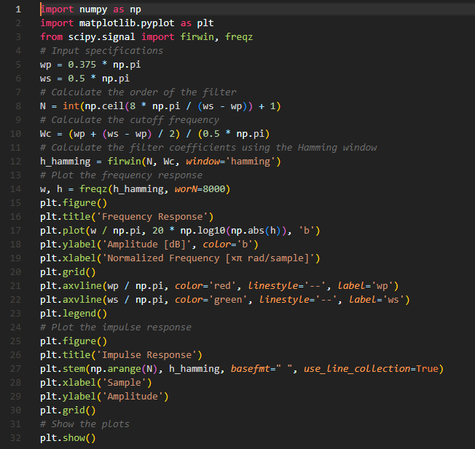
The results (Screenshot)
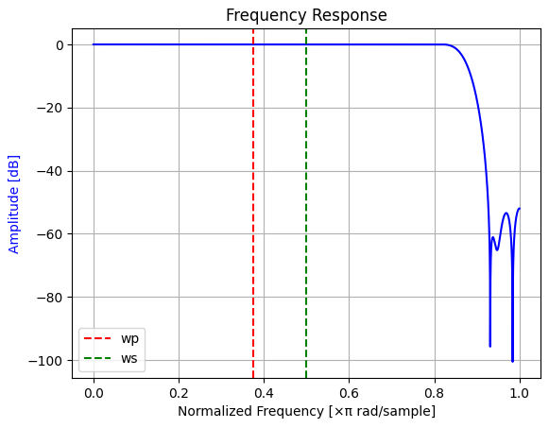
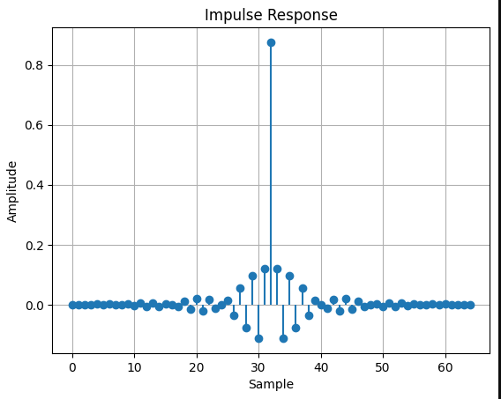

Lab Task No 2:

Solution:
Brief description (3-5 lines)
Blackman Window:
Write a Python program to design an FIR filter using the Blackman window. Perform the following steps:
Define the input specifications: wp = 0.375 * np.pi, ws = 0.5 * np.pi.
Calculate the order of the filter using the formula N = int(np.ceil(8 * np.pi / (ws - wp)) + 1).
Calculate the cutoff frequency: Wc = (wp + (ws - wp) / 2) / (0.5 *np.pi).
Calculate the filter coefficients using the Blackman window: h_blackman = firwin(N, Wc,window='blackman').
The code
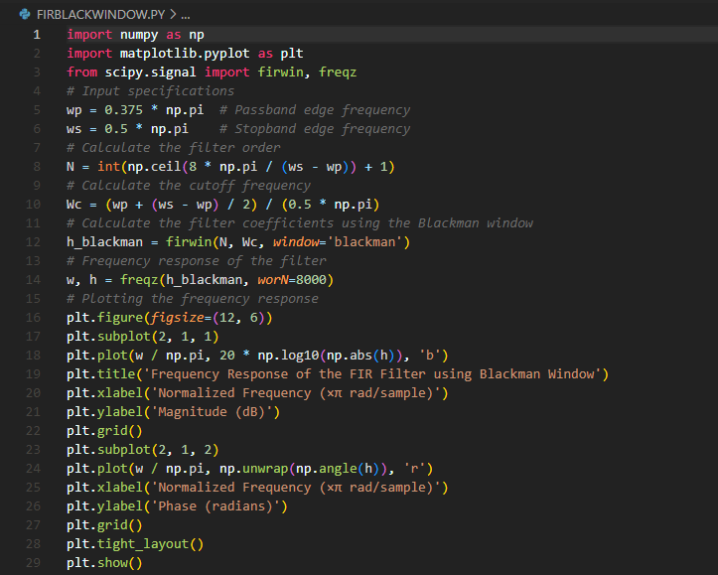
The results (Screenshot)
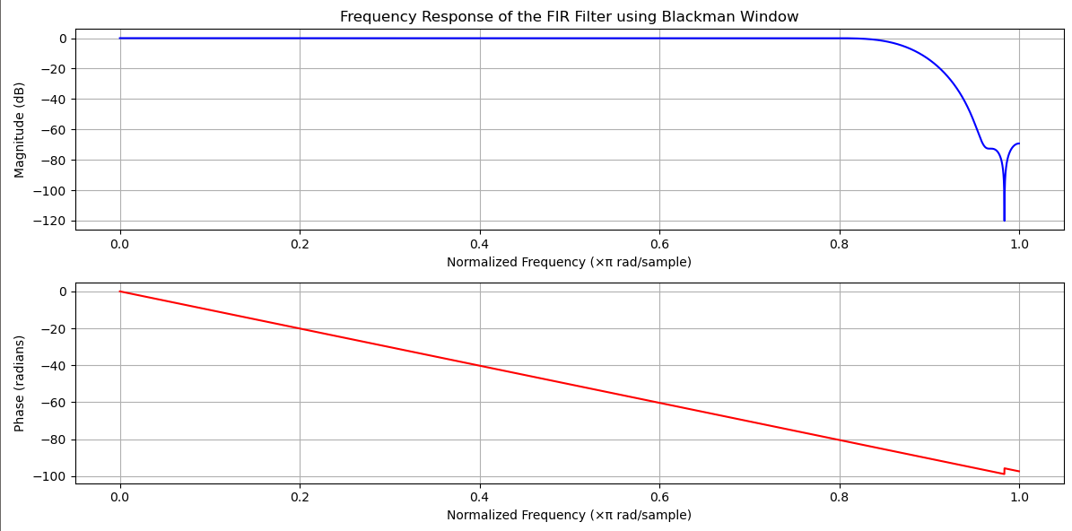

Lab Task No 3:

Solution:
Brief description (3-5 lines)
Kaiser Window:
Write a Python program to design an FIR filter using the Kaiser window. Perform the following steps:
Define the input specifications: wp = 0.375 * np.pi, ws = 0.5 * np.pi.
Calculate the order of the filter using the formula N = int(np.ceil(8 * np.pi / (ws - wp)) + 1).
Calculate the cutoff frequency: Wc = (wp + (ws - wp) / 2) / (0.5 * np.pi).
Set the beta parameter for the Kaiser window: beta = 8.
Calculate the filter coefficients using the Kaiser window: h_kaiser = firwin(N, Wc, window=('kaiser',beta)).
Plot the frequency response and impulse response for the Kaiser window.
Display the plots.
The code
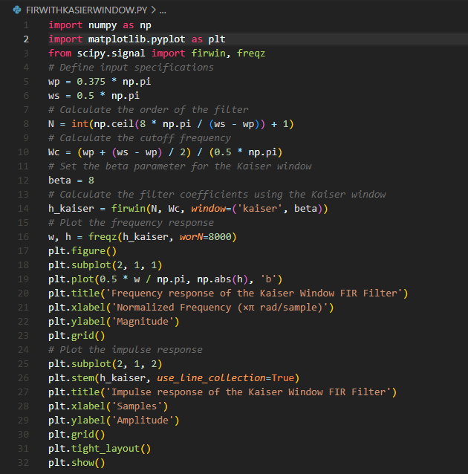
The results (Screenshot)
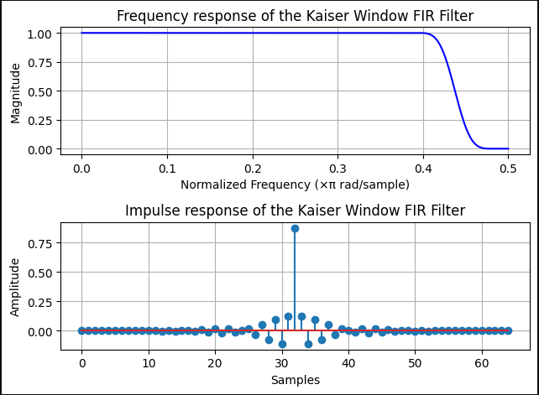

Lab Task No 4:

Solution:
Brief description (3-5 lines)
Implementation of IIR Filters
Design three different IIR filters using the given specifications:
Filter order: 4
Cutoff frequency: 0.2 (normalized frequency)
Algorithm 1: Butterworth Filter
Use the butter function from SciPy to design a Butterworth filter with the given order and cutoff frequency.
Obtain the filter coefficients b_butter and a_butter.
The code
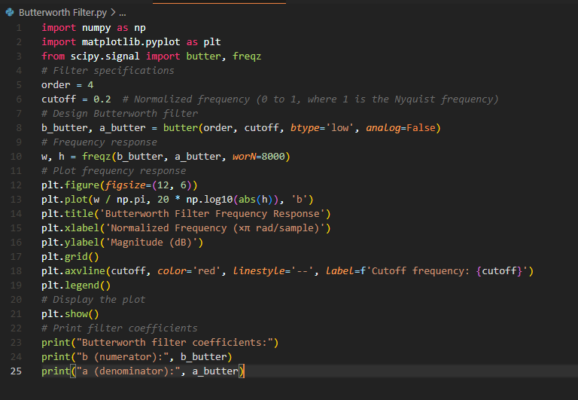
The results (Screenshot)
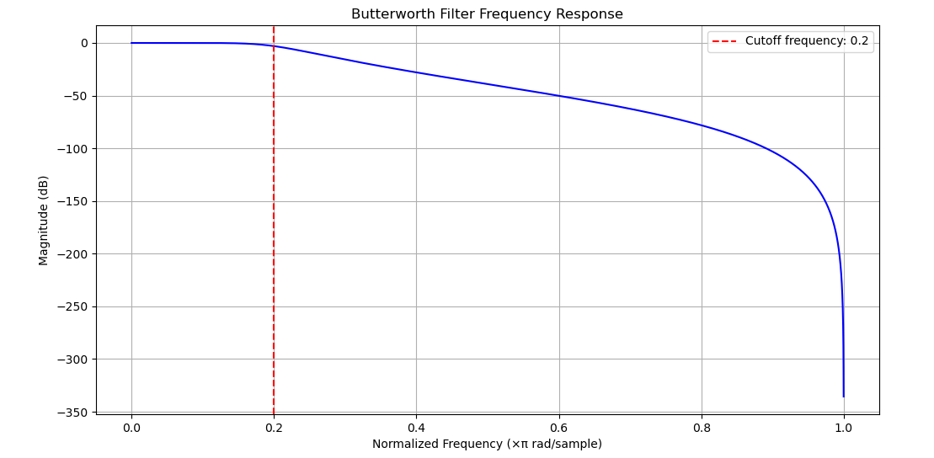

Lab Task No 5:

Solution:
Brief description (3-5 lines)
Algorithm 2: Chebyshev Type I Filter
Set the passband ripple to 1 dB.
Use the cheby1 function from SciPy to design a Chebyshev Type I filter with the given order,
passband ripple, and cutoff frequency.
Obtain the filter coefficients b_cheby1 and a_cheby1.
The code
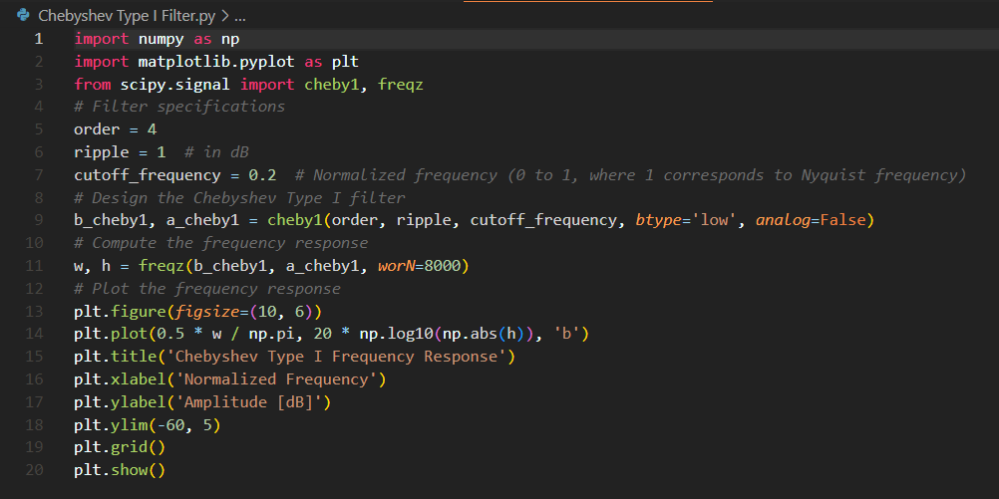
The results (Screenshot)
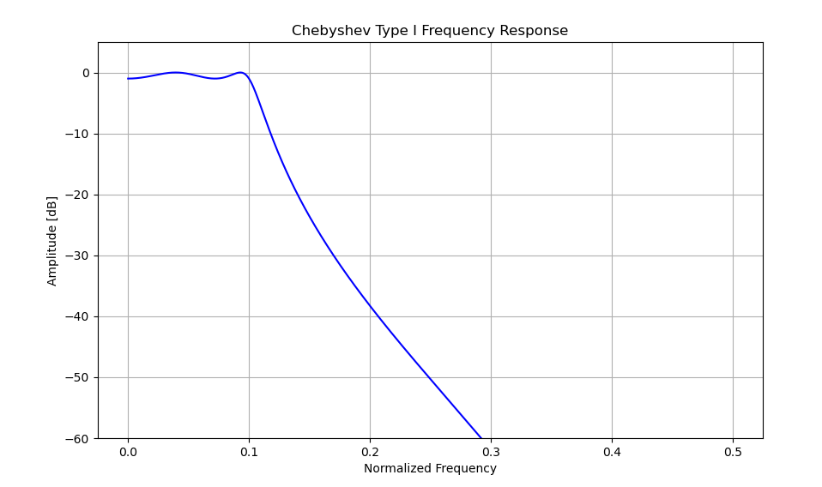

Lab Task No 6:

Solution:
Brief description (3-5 lines)
Algorithm 3: Elliptic Filter
Set the passband ripple to 1 dB and the stopband attenuation to 40 dB.
Use the ellip function from SciPy to design an elliptic filter with the given order, passband
ripple, stopband attenuation, and cutoff frequency.
Obtain the filter coefficients b_ellip and a_ellip.
Plot the magnitude response for each filter:
Compute the frequency response of each filter using the freqz function from SciPy.
Plot the magnitude response of the Butterworth filter using plt.plot(w, np.abs(h_butter),
label='Butterworth').
Plot the magnitude response of the Chebyshev Type I filter using plt.plot(w, np.abs(h_cheby1),
label='Chebyshev Type I').
Plot the magnitude response of the elliptic filter using plt.plot(w, np.abs(h_ellip),
label='Elliptic').
Set the title to 'Magnitude Response' using plt.title('Magnitude Response').
Set the x-axis label to 'Frequency (radians)' using plt.xlabel('Frequency (radians)').
Set the y-axis label to 'Magnitude' using plt.ylabel('Magnitude').
Display the legend using plt.legend().
Enable grid lines using plt.grid(True).
Plot the phase response for each filter:
Plot the phase response of the Butterworth filter using plt.plot(w, np.angle(h_butter),
label='Butterworth').
Plot the phase response of the Chebyshev Type I filter using plt.plot(w, np.angle(h_cheby1),
label='Chebyshev Type I').
Plot the phase response of the elliptic filter using plt.plot(w, np.angle(h_ellip), label='Elliptic').
Set the title to 'Phase Response' using plt.title('Phase Response').
Set the x-axis label to 'Frequency (radians)' using plt.xlabel('Frequency (radians)').
Set the y-axis label to 'Phase (radians)' using plt.ylabel('Phase (radians)').
Display the legend using plt.legend().
Enable grid lines using plt.grid(True).
Display the plots using plt.show().
The code
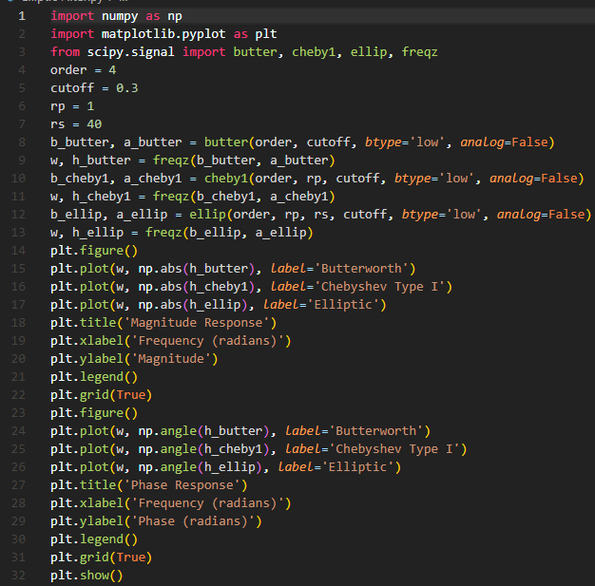
The results (Screenshot)
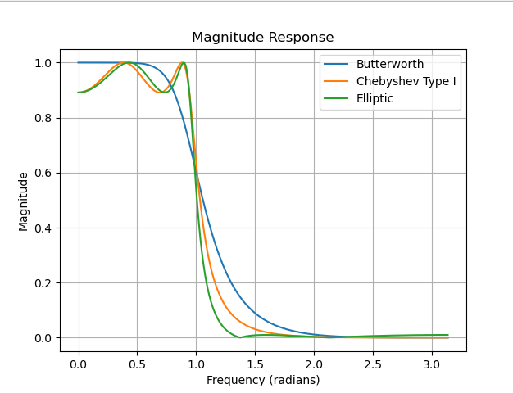
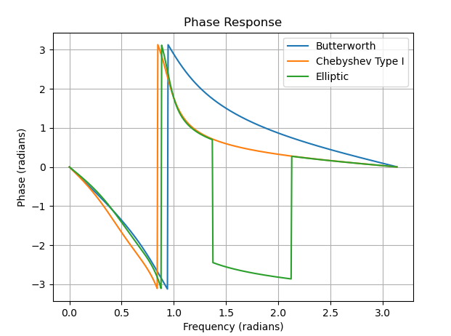

Conclusion
In conclusion, digital signal processing (DSP) employs filters like FIR (Finite Impulse Response) and IIR (Infinite Impulse Response) to manipulate signal characteristics. FIR filters offer stability and a linear phase response, while IIR filters provide computational efficiency with potential for instability.

